**Implement program for decomposing time series data into trend and seasonality run in python code**

**EX.No:6**

**DATE:**

**AIM:**

To implement a Python program to decompose time series data into Trend, Seasonality, and Residual

components for pattern analysis and forecasting.

**ALGORITHM:**

1. Import pandas, matplotlib, and statsmodels libraries.
2. Load the dataset and convert the date column to datetime.
3. Set date as index and resample the data.
4. Apply seasonal_decompose() to split data into trend, seasonality, and residual.
5. Plot and visualize all components.

**CODE:**

import pandas as pd

import matplotlib.pyplot as plt

import seaborn as sns

from statsmodels.tsa.seasonal import seasonal_decompose

df = pd.read_csv('Plant_1_Generation_Data.csv')

df['DATE_TIME'] = pd.to_datetime(df['DATE_TIME'], errors='coerce')

print(f"Shape of the DataFrame: {df.shape}")

print("\nMissing Values:\n", df.isnull().sum())

print("\nData Types:\n", df.dtypes)

print("\nDescriptive Statistics for Numerical Columns:\n", df.describe())

df = df.set_index('DATE_TIME')

df_resampled = df.select_dtypes(include=['number']).resample('D').mean()

decomposition = seasonal_decompose(df_resampled['DC_POWER'], model='additive', period=7)

plt.figure(figsize=(16, 12))

plt.subplot(4, 1, 1)

plt.plot(df_resampled.index, df_resampled['DC_POWER'], color='blue')

plt.xlabel("Date")

plt.ylabel("DC Power")

plt.title("Original Time Series")

plt.subplot(4, 1, 2)

plt.plot(df_resampled.index, decomposition.trend, color='green')

plt.xlabel("Date")

plt.ylabel("Trend")

plt.title("Trend Component")

plt.subplot(4, 1, 3)

plt.plot(df_resampled.index, decomposition.seasonal, color='red')

plt.xlabel("Date")

plt.ylabel("Seasonality")

plt.title("Seasonal Component")

plt.subplot(4, 1, 4)

plt.plot(df_resampled.index, decomposition.resid, color='purple')

plt.xlabel("Date")

plt.ylabel("Residuals")

plt.title("Residual Component")

plt.tight_layout()

plt.show()

**OUTPUT:**

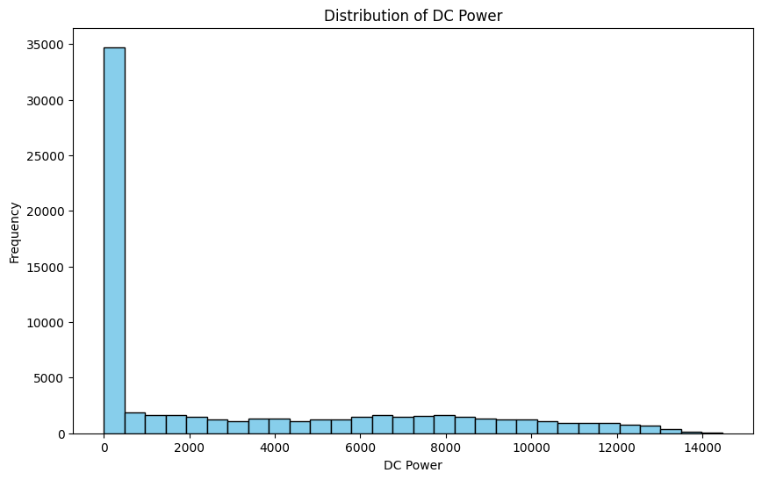

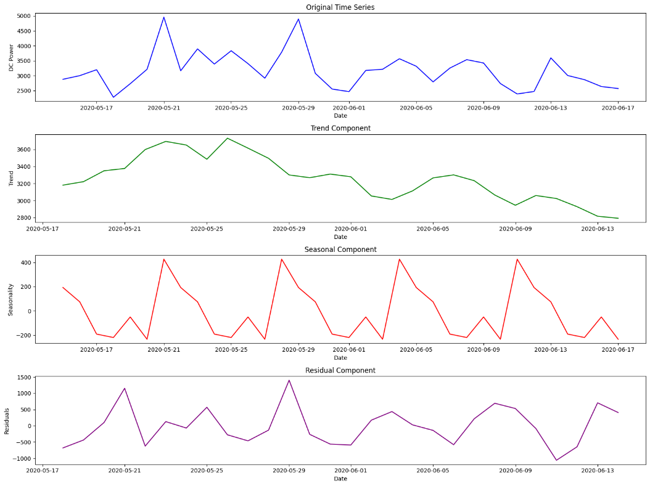

**RESULT:**

Thus the program has been completed and verified successfully.